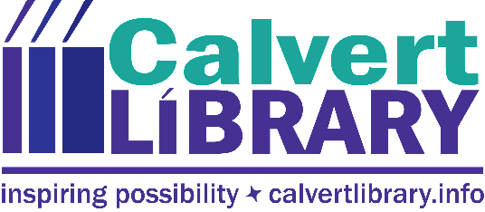

Calvert Library Staff Member Positive for COVID
January 10, 2022
FOR IMMEDIATE RELEASE
Contact: Robyn Truslow
410-535-0291
A member of Calvert Library Prince Frederick staff has tested positive for the COVID-19 virus. The staff member worked in the public space on Friday, January 7, from 12pm to 5pm.
The staff member worked with the public following library COVID-protocol; had no close contact with customers, maintained 6 feet of social distance, washed/sanitized their hands regularly and wore a mask covering their nose and mouth at all times while in the public space. Risk should be minimal to any library customers, but please follow Health Department guidance or your physician’s recommendations if you visited the library during the affected time period.
Staff members who had close contact but are fully vaccinated are consistently wearing masks over their nose and mouth and closely monitoring their health for possible symptoms per Health Department guidance.
Please know that the safety of our staff and the public we serve is our top priority. We will continue to take the proper precautions and promote social distancing. The CDC continues to recommend that you wear a mask over your nose and mouth when in public spaces, wash your hands frequently with soap and water, avoid touching your face and make sure to practice social distancing by staying at least 6 feet away from others. If you are feeling ill, please stay home.

We will continue to work together through this difficult time, and we will continue to keep you informed of any new information over the course of this pandemic.

For more information call 410-535-0291.
###

Related Links

Robyn Truslow
Public Relations Coordinator
Calvert Library
850 Costley Way
Prince Frederick, MD 20678
410-535-0291
410-535-3022 Fax
rtruslow@calvertlibrary.info

